**SHELL – FINAL CASE STUDY ASSESSMENT**

1. PROJECT MANAGEMENT SETUP

* Create a new project in Azure Boards.

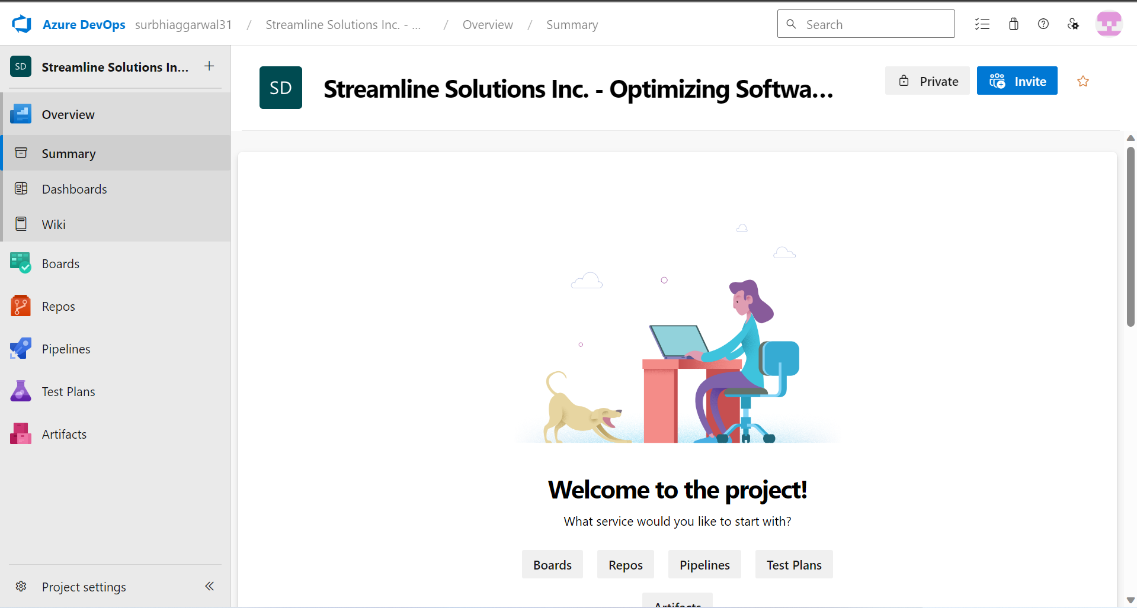

* Create Epic , features ,Product backlogs and tasks. Relate them using parent child relationship. Hierarchy is displayed below.

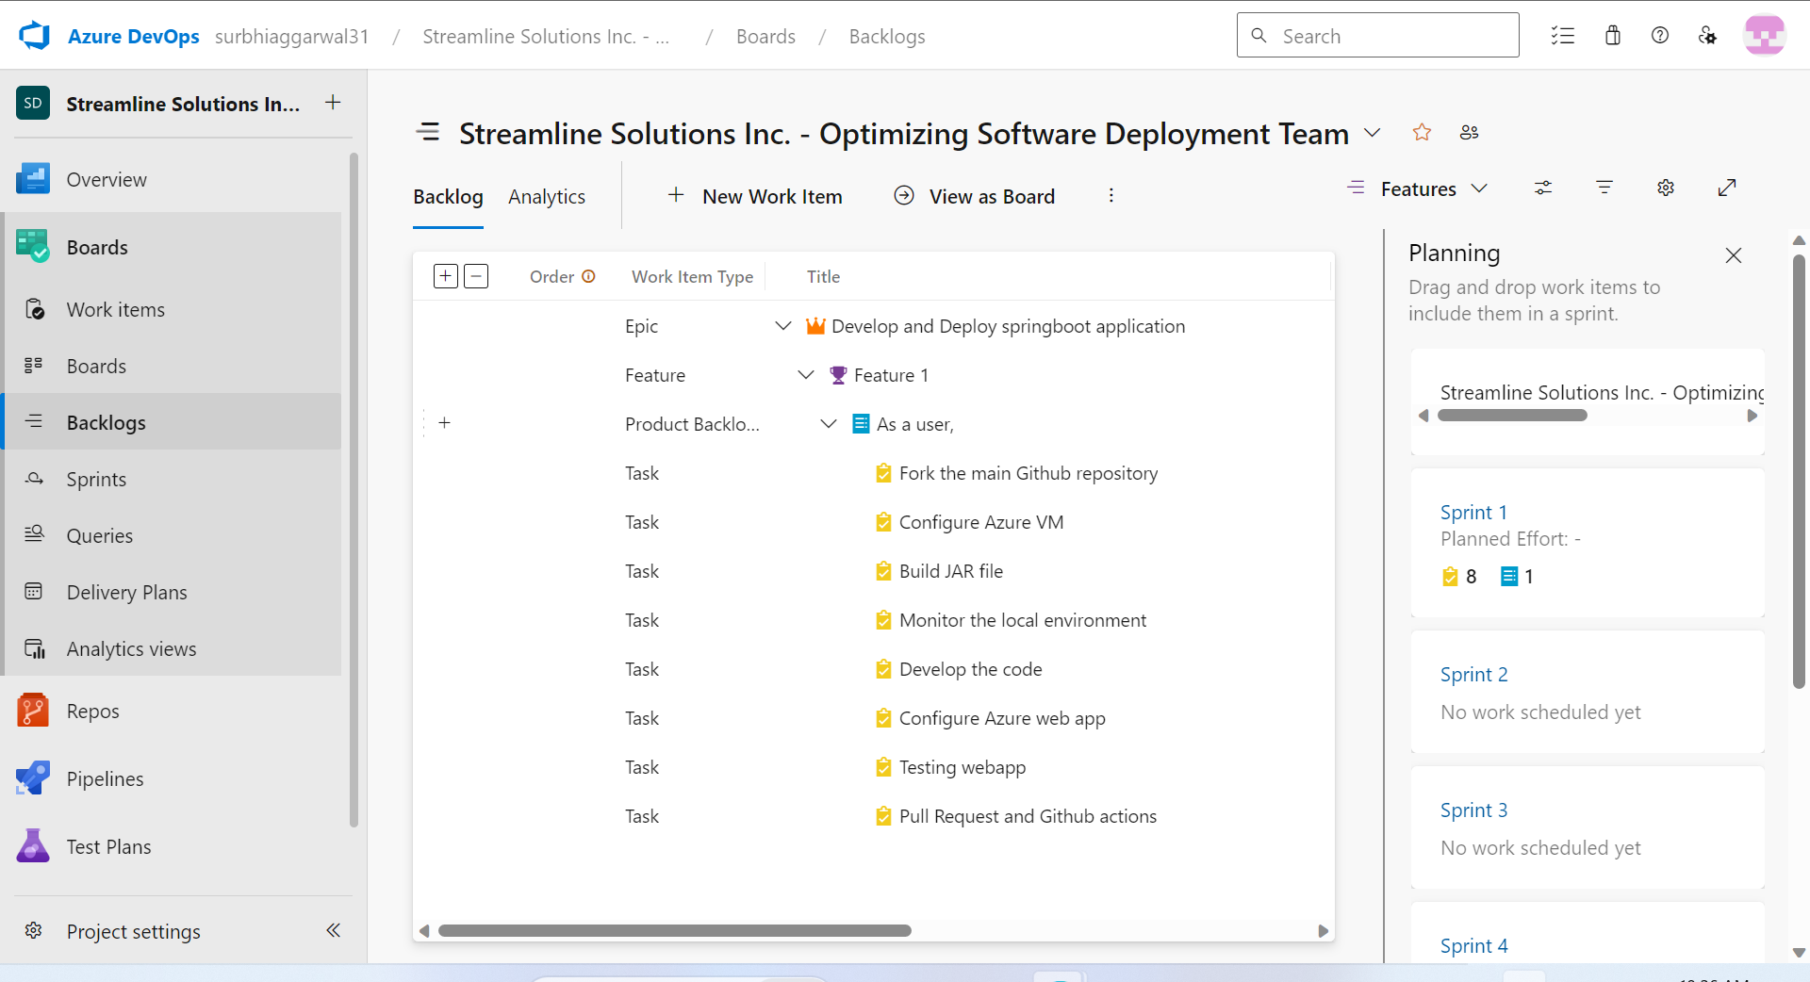

* Move product backlog to sprint backlog.

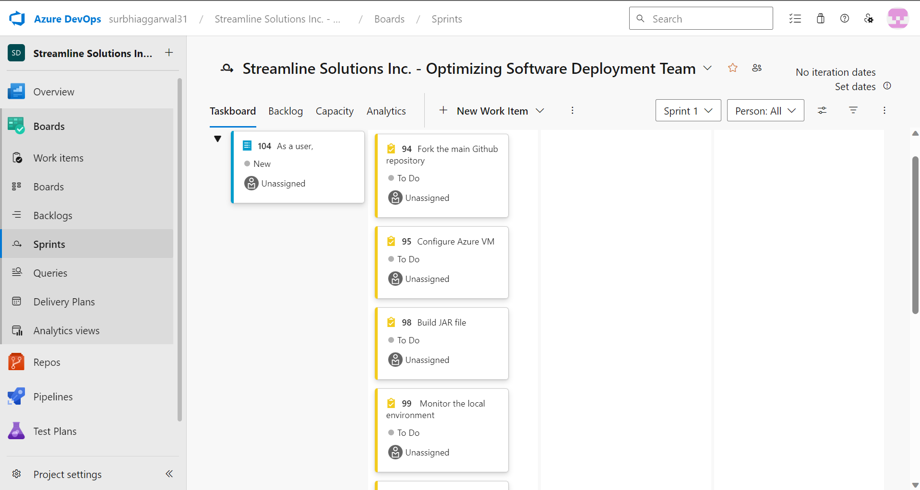

1. GitHub Repository and Feature Branching

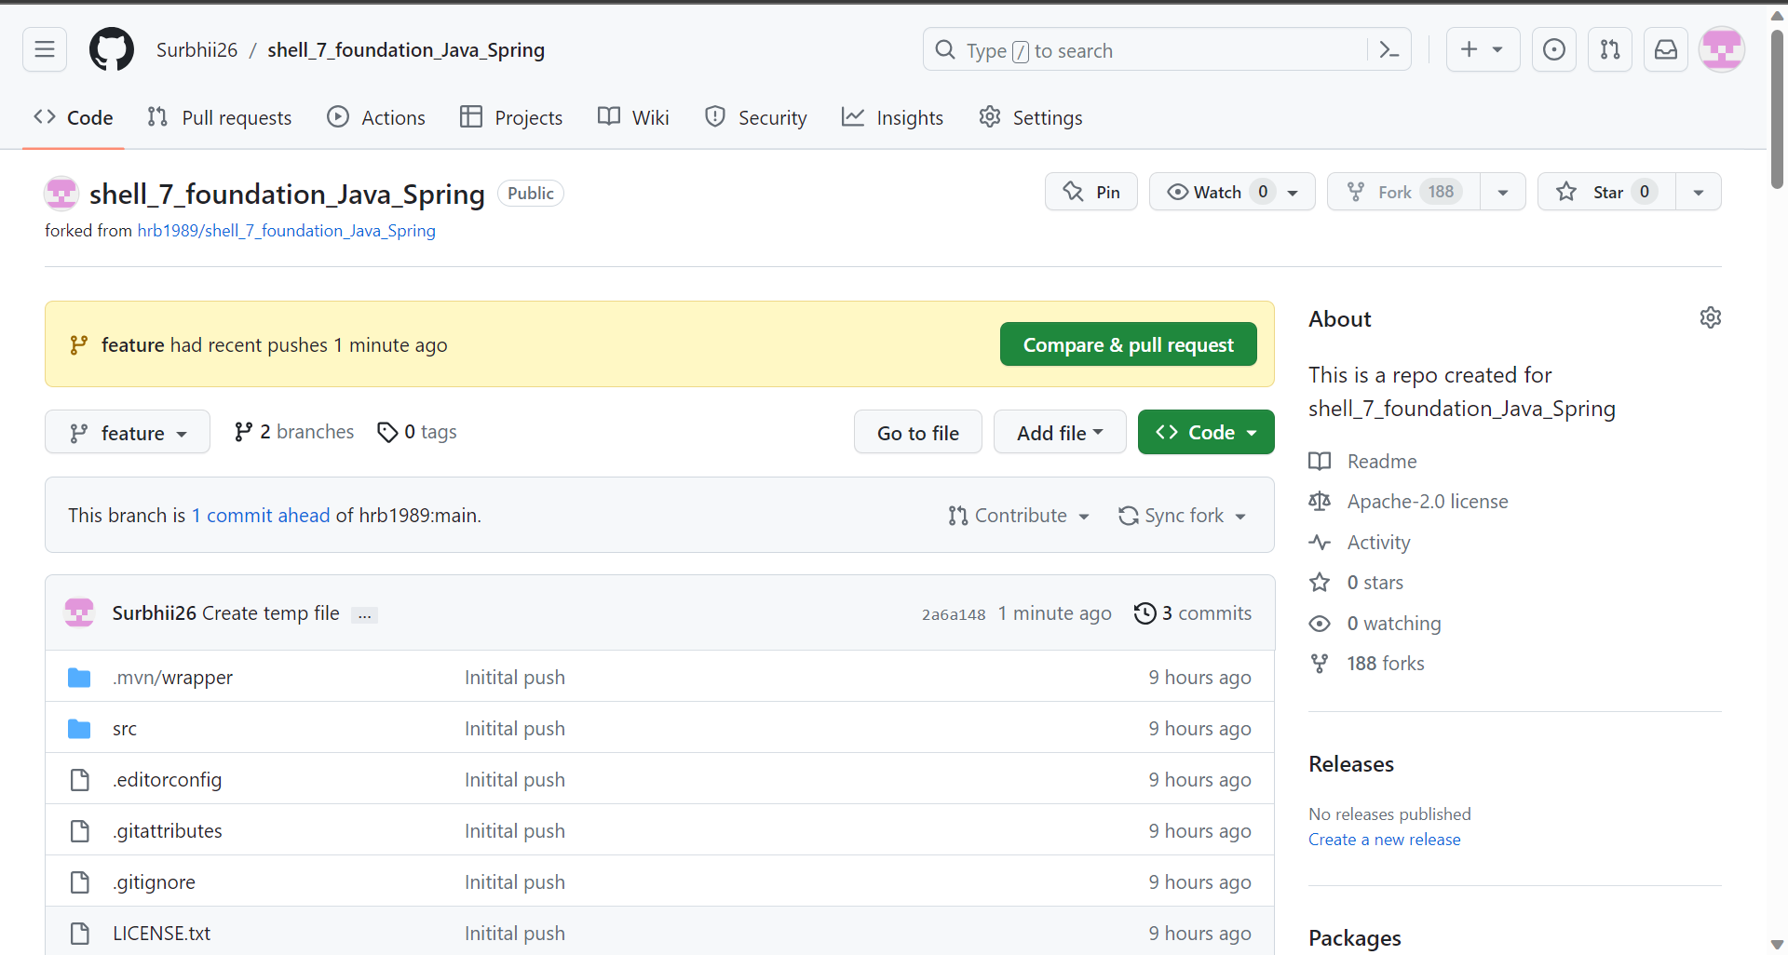

1. Azure VM Configuration

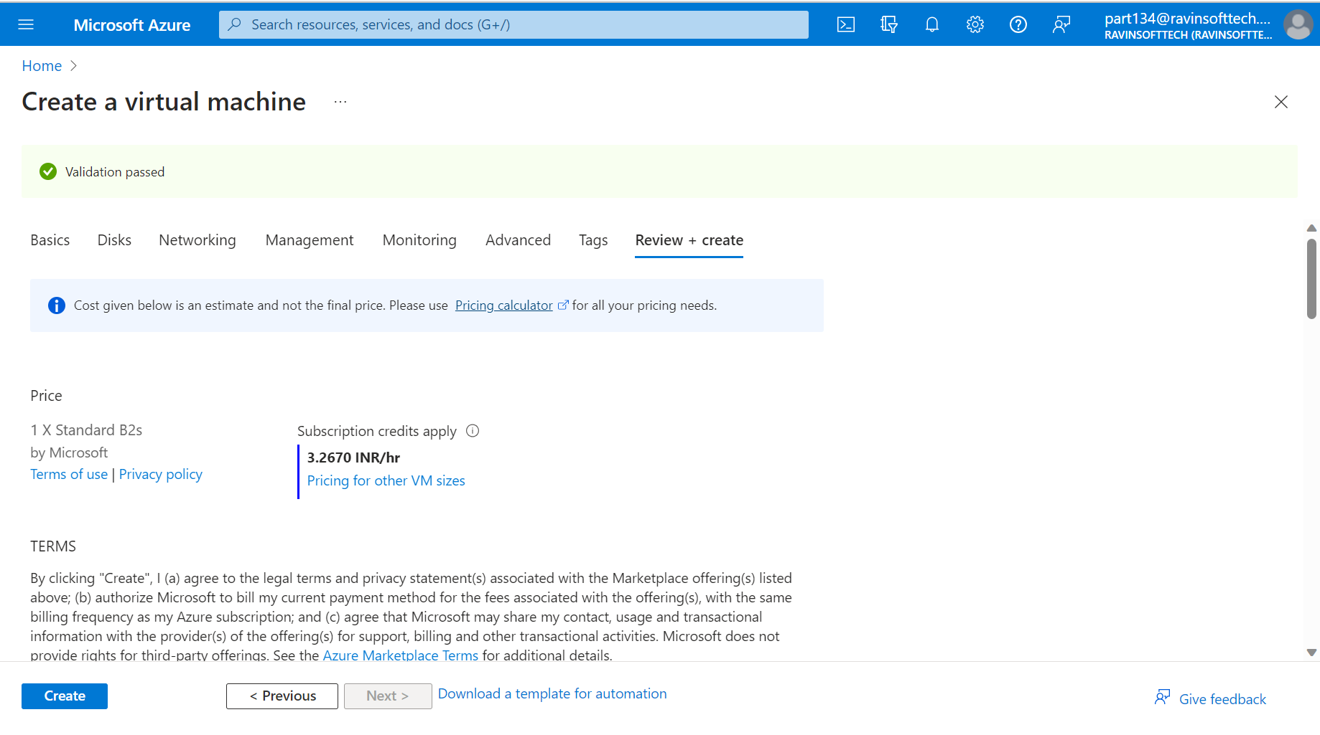

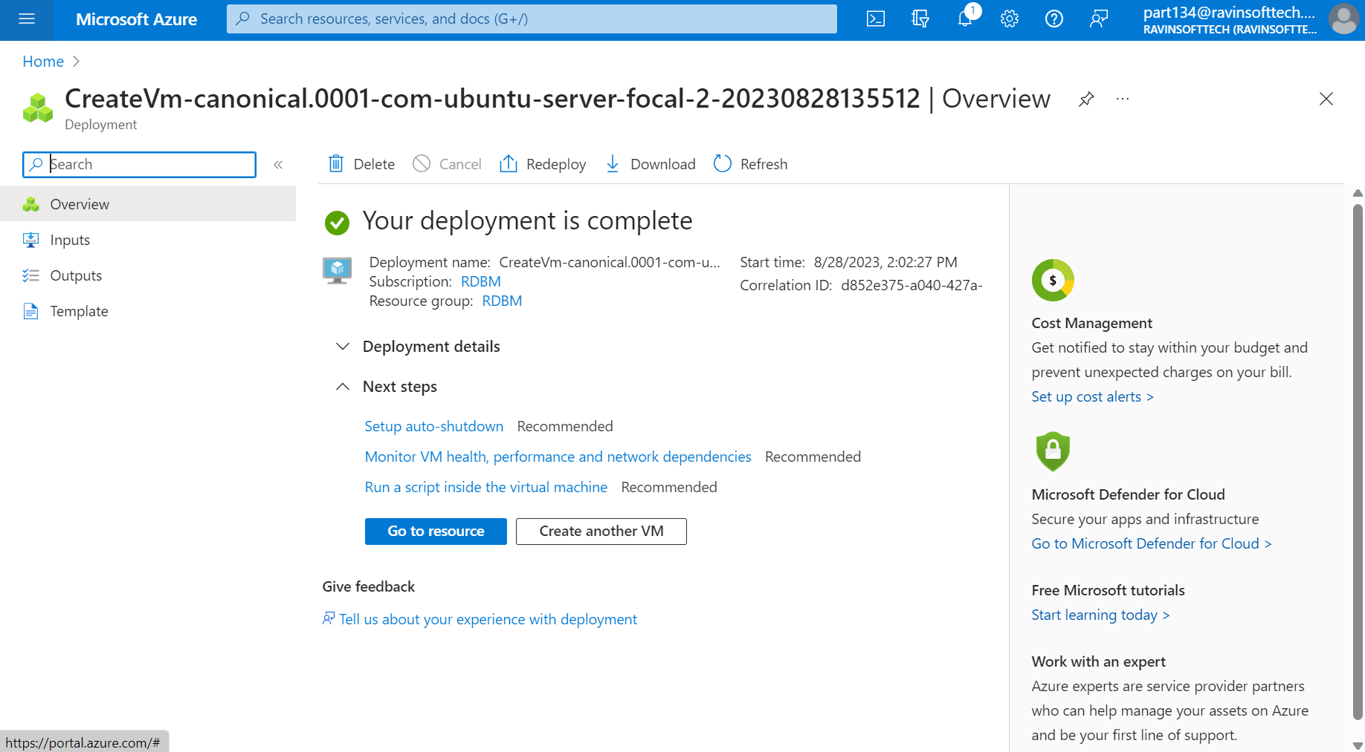

1. Maven Build Process and Prometheus Integration monitoring

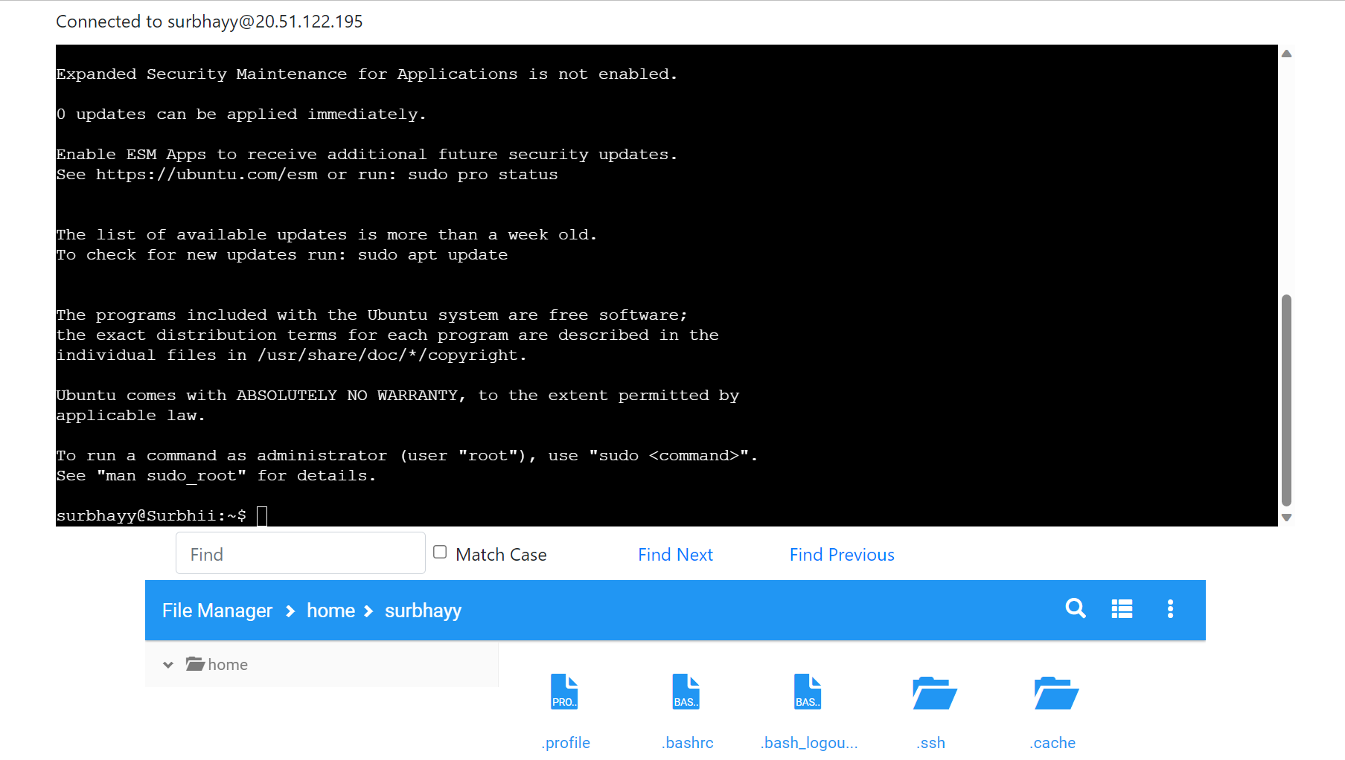

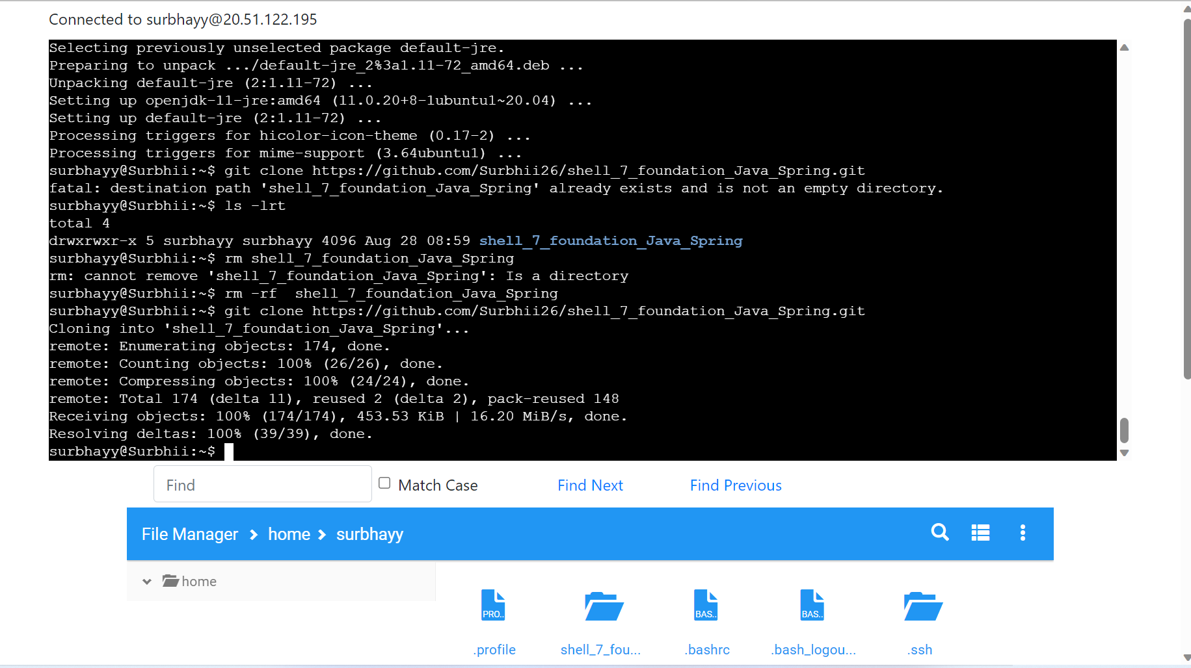

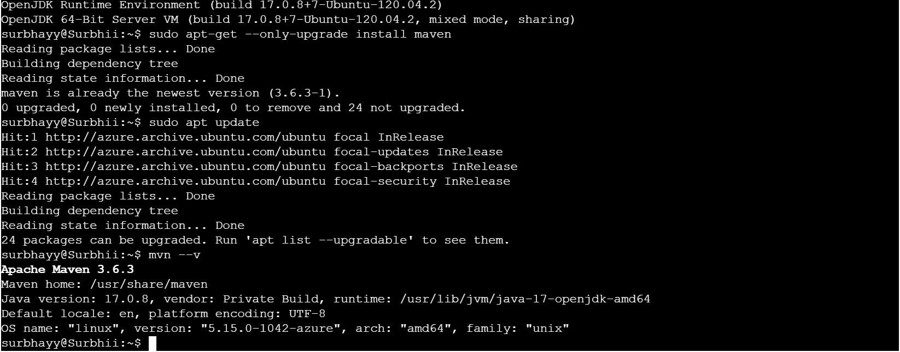

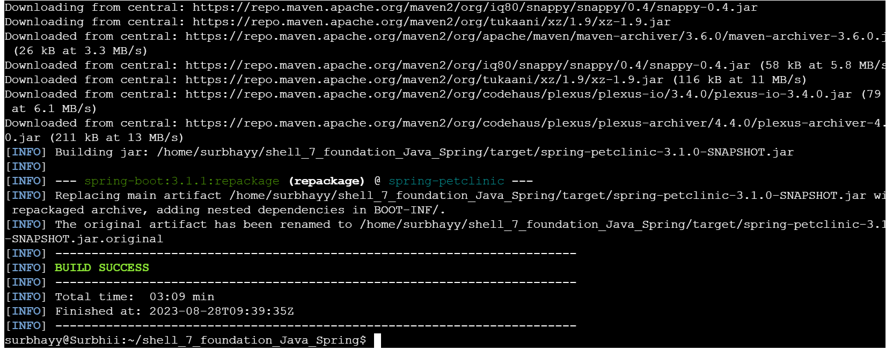

1. Prometheus Integration

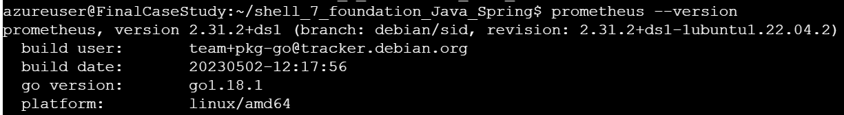

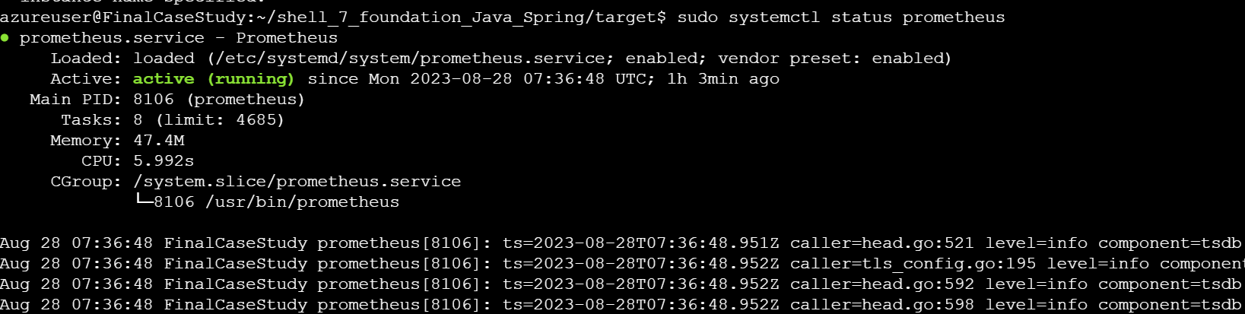

1. Install Docker and run Dockerfile

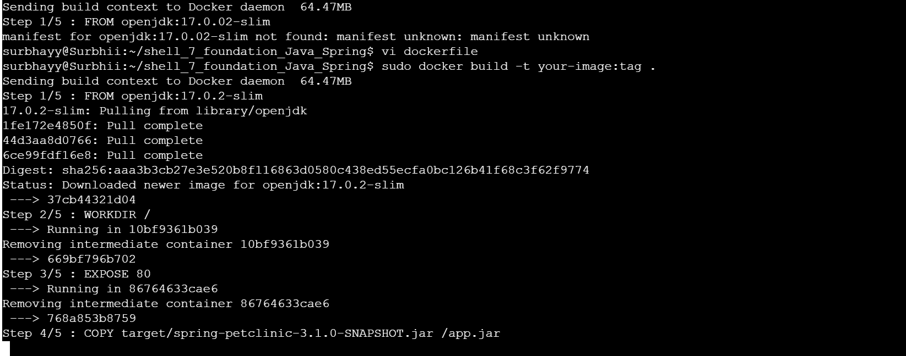

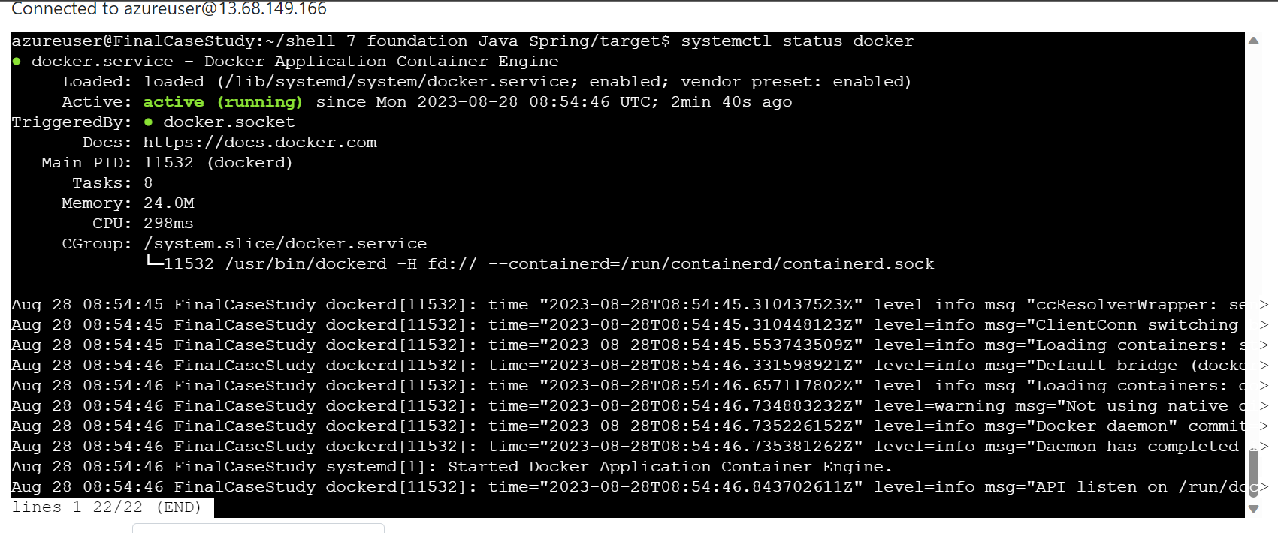



1. Docker Image Pushed and created webapp

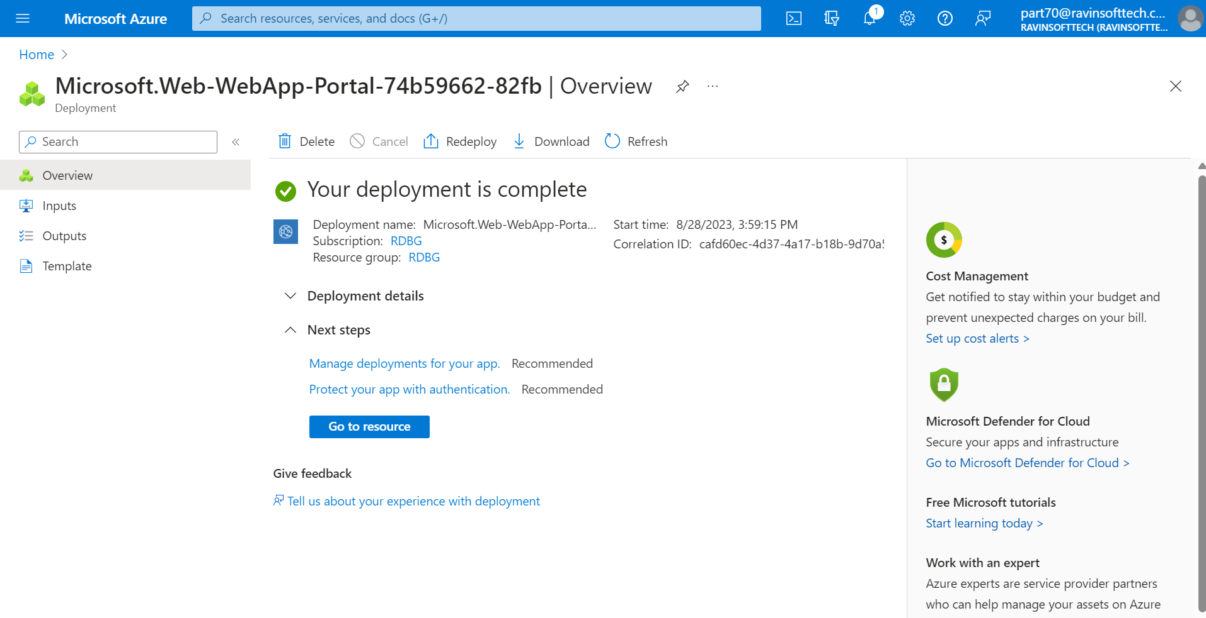

1. Pull request collaboration

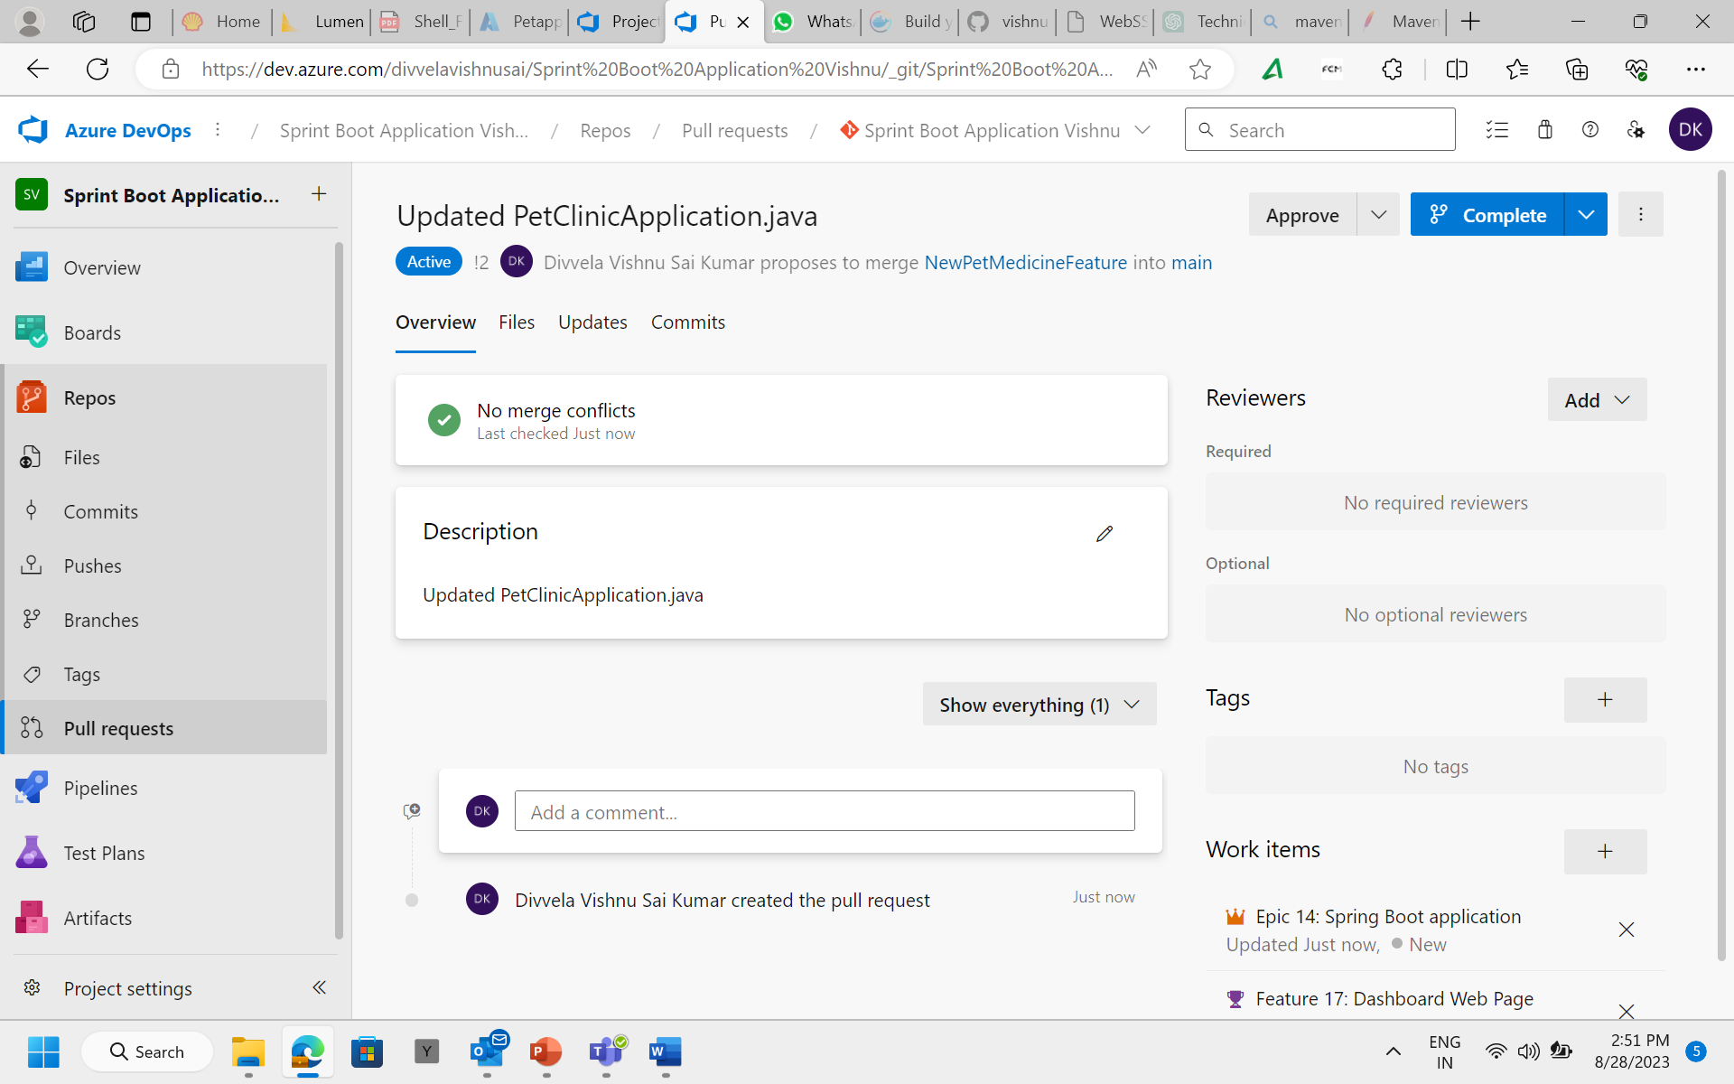

1. Github actions workflow implementation and testing

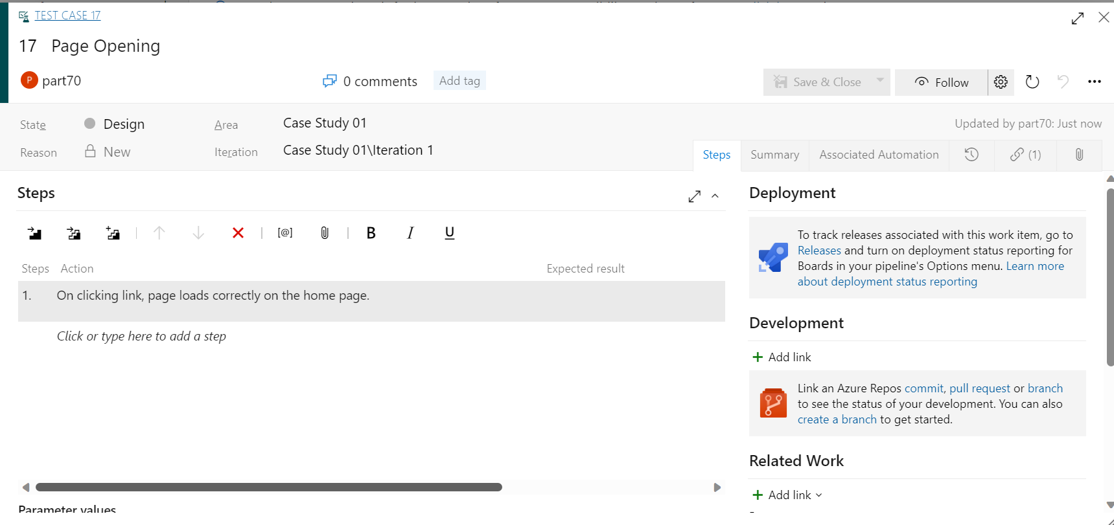

1. Azure Boards Tasks and Sprint Closure:

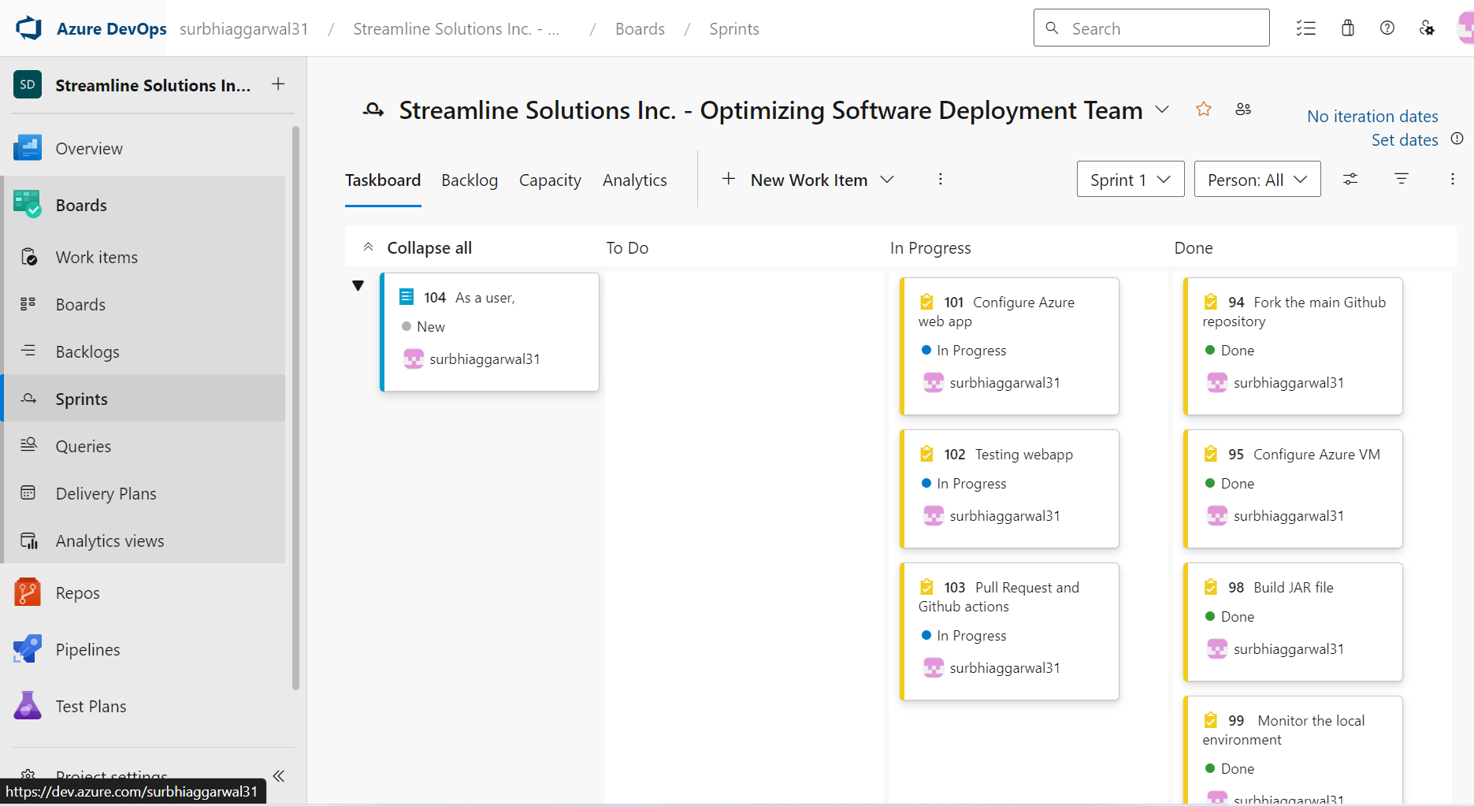

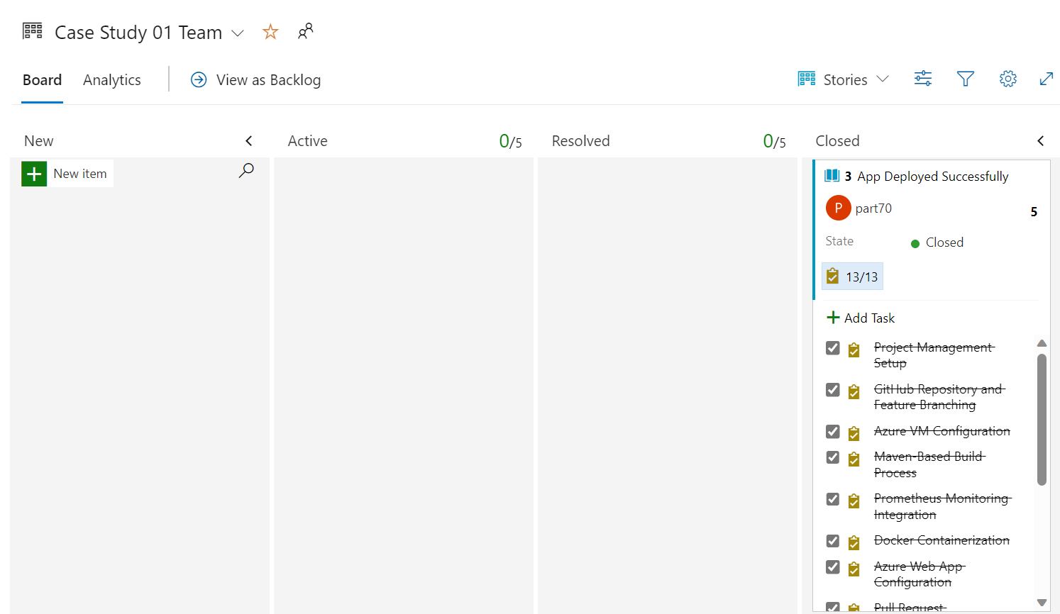

1. Outcome

I've learned how to work with a sprint, and having implemented the app in tight timeframes, it has taught me time management skills as well as my ability to manage pressure. I learnt about deploying an app on azure, created a dockerfile and docker image, devops, agile, git, github workflow, etc. Streamline Solutions Inc. aims at delivering rapid and reliable software deployment, since the CICD Workflow has been systematically implemented.